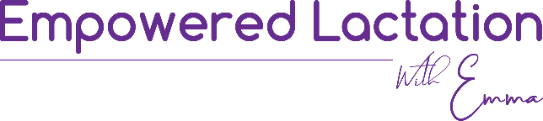 Initial Consult Questionnaire
Name: D.O.B
Babys Name and DOB/Gestation: Partners Name and Age:
Other Children’s Names and ages:

Address:
Mobile: Email:
General Practitioners name & number:
Private Health Fund:
Have you breastfed previously? What was your experience like?

What are your concerns regarding breastfeeding?

Do you have a history of: diabetes, thyroid disease, breast implants, allergies, asthma, epilepsy, cold sores, food intolerances, vision or hearing impairments, blood borne diseases, high blood pressure, any recent infections? Any other relevant medical history?

Have you experienced depression and/or anxiety or other mental health conditions?

Do you smoke? Do you drink alcohol or use other drug substances?
Do you take any medications or herbal supplements? If so what/how much?

What is your intented mode of birth ?
If birthed you baby already what was your experience like? Were there complications?

Have you been been unwell with flu like symptoms or returned from overseas or any known hot spots recently?
Have you had any known contact of anyone with Sars-Cov-2 infection? YES/NO
Do you give permission for Emma to take photographs for private documentation YES/NO social media use YES/NO
Text message is often an easy method of communication, although not classed ‘privacy safe’, do you give permission to use text messaging for ongoing communication? YES/NO
Where abouts did you find Empowered Lactation? (eg: friend, midwife, online search, instagram etc):

